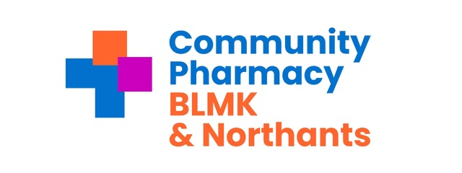

May 13th 2026 from 09.30 online

BLMK & Northants LPC meeting | Meeting-Join | Microsoft Teams

Attendees:

Nishil Shah - Chair and Independent LPC Member (Retrolink Ltd) NS
Mahesh Shah - Vice Chair and Independent LPC Member (Sampson AP Ltd) MS
Anne-Marie King - Chief Officer AMK
Paul Fearon - Treasurer PF
Ingrid Cruickshank - Services & Engagement Lead BLMK IC
Ann-Marie Carrey Services & Engagement Lead BLMK AC
Rita Patel Services & Engagement Lead Northants RP

Rishi Hindocha - Independent LPC Member (Pharmacy Cherry) RH
Amit Lakhani - Independent LPC Member (Bishopscote Chemist) AL
Nabeel Amirudin – LPC Member, Independent LPC Member (Regent Pharmacy) NA

Lakhminder Flora - LPC Member, CCA representative (Boots) LF
Gordon Ross - LPC Member, CCA representative (Boots) GR
Tahera Dewji- LPC Member, CCA representative (Superdrug) TD

Has Modi - LPC Member, AIMp representative (Jardines - UK Ltd) HM
Conor Steele - LPC Member, AIMp representative (Jardines - UK Ltd) CS

Apologies :
Rita Patel
Maria Wogan- Director of Neighbourhood Health & Partnerships Central East ICB for BLMK
Anil Sharma

Time | Agenda Item | Presenter
09.30 | Welcome and Introductions | NS
 | Apologies for absence
 | Declarations of Interests | All
 | Confirm accuracy of previous minutes | All
 | Vacancy IPA member | NS
09.50 | Treasurer’s update | PF
10.10 | Vote to approve accounts to year ending 31.3.26
10.20 | Governance | Governance sub committee
10.30 | Amanda Flowers and Sonal Mehta Central East ICB
10.50 | LLR BLMK-N boundary change
11.10 | Central East LPC Collaborative update | NS
11.30 | CCA Quarterly Questions (if required) | CCA Members
11.40 | Contractor Event | Service engagement team
12.00 | Matters Arising | NS
12.15 | AOB | ALL
12.25 | Concluding Comments | NS
12.30 | Close of Meeting | NS

Next Meeting in person Wednesday June 24th 2026

