
CGL Monthly Supervised/Unsupervised Dispensing
How to claim correctly.
- At the end of the month a claim should be submitted for all service users that are registered at your pharmacy (supervised and unsupervised).
- A monthly activity fee is payable for all service users dispensed 10 days of medication and additionally a supervision fee is payable for each supervision undertaken.
- The service user must be registered via the Registration for all CGL MAT clients before entering on the monthly template.
Only one claim should be submitted per service user per month. The need to record prescription dates or enter individual supervisions has been removed. Please only record the total number of supervisions per month and not per individual prescription.
If multiple claims are made per service user, you will be notified to remove the duplicate claims and amend the claim appropriately. This may delay payments.

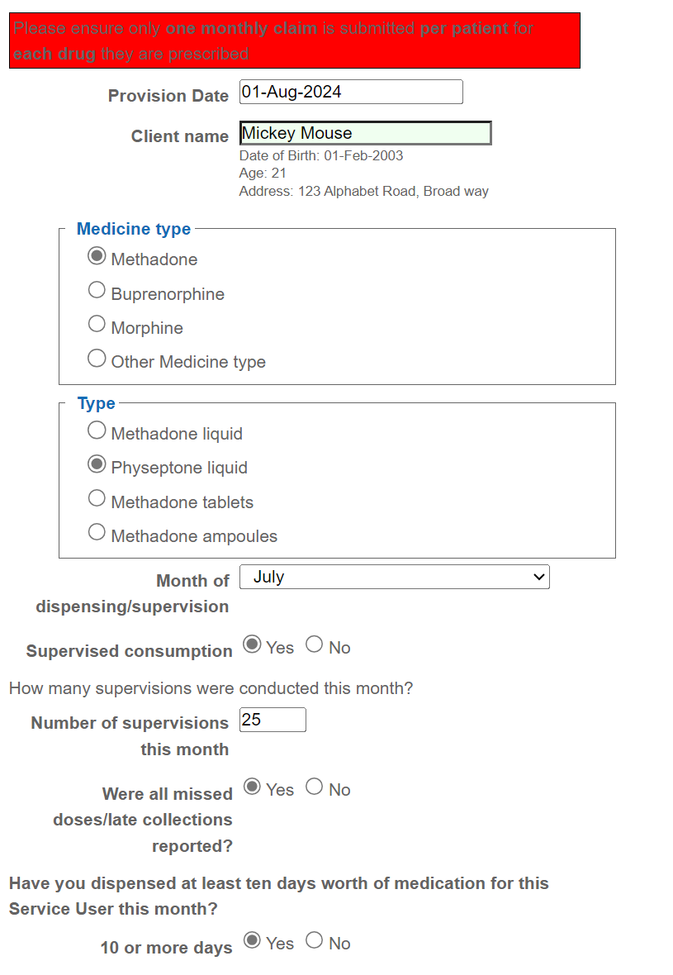
For supervised consumption clients:
- Select the date you are making the claim.
- Select the client.
- Select the medicine type e.g. Methadone.
- Select the medicine form/ brand where applicable e.g. Physeptone.
- Select the Month you are claiming for e.g. July.
- If the service user is supervised select “yes” for supervised consumption and total up the number of supervisions for that month and enter in the box.
- Declare that you have reported all missed/late doses. If you have not reported all missed/late doses, you will be prompted to do so.
- Declare whether you dispensed 10 or more days of medication to the service user to activate the monthly activity fee.

For non-supervised consumption clients:
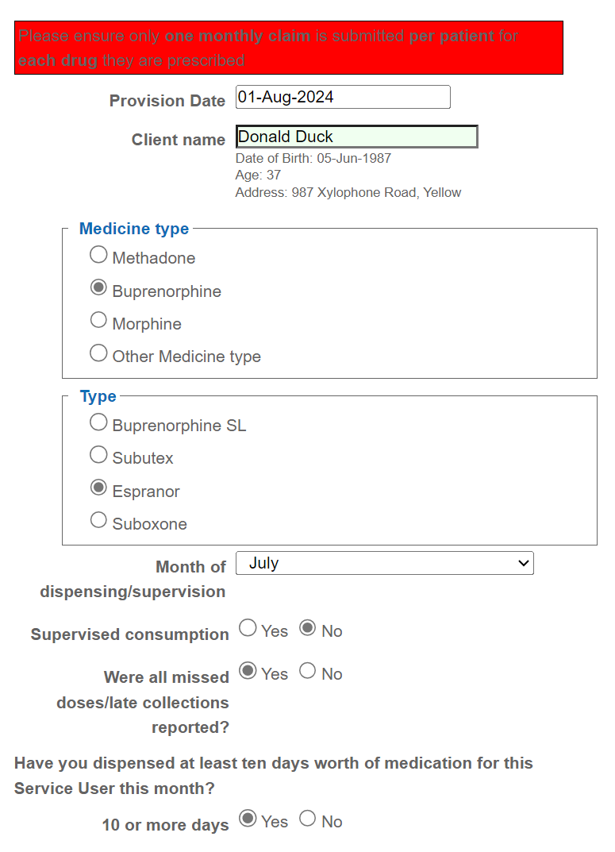
- Select the date you are making the claim.
- Select the client.
- Select the medicine type e.g. buprenorphine.
- Select the medicine form/ brand where applicable e.g. Espranor.
- Select the Month you are claiming for e.g. July.
- Select that the service user is not supervised.
- Declare that you have reported all missed/late doses. If you have not reported all missed/late doses, you will be prompted to do so.
- Declare whether you dispensed 10 or more days of medication to the service user to activate the monthly activity fee.

