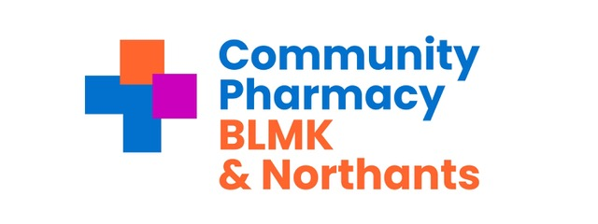
Microsoft Teams meeting
Join: https://teams.microsoft.com/meet/37538623253292?p=tUdXGQbB9SjVmEmod7
Meeting ID: 375 386 232 532 92
Passcode: 6Qa2Ks3M

Wednesday 21st January 2026 from 09:30 am

Attendees:

Nishil Shah - Chair and Independent LPC Member (Retrolink Ltd) NS
Mahesh Shah - Vice Chair and Independent LPC Member (Sampson AP Ltd) MS
Anne-Marie King - Chief Officer AMK
Paul Fearon - Treasurer PF
Ingrid Cruickshank - Services & Engagement Lead BLMK IC
Ann-Marie Carrey Services & Engagement Lead BLMK AC
Rita Patel Services & Engagement Lead Northants RP

Rishi Hindocha - Independent LPC Member (Pharmacy Cherry) RH
Viren Bhatia - Independent LPC Member (Kalki Health Ltd) VB
Amit Lakhani - Independent LPC Member (Bishopscote Chemist) AL

Lakhminder Flora - LPC Member, CCA representative (Boots) LF
Gordon Ross - LPC Member, CCA representative (Boots) GR
Tahera Dewji- LPC Member, CCA representative (Superdrug) TD

Has Modi - LPC Member, AIMp representative (Jardines - UK Ltd) HM
Conor Steele - LPC Member, AIMp representative (Jardines - UK Ltd) CS
Mohammed Salloo- LPC Member, AIMp representative (Peak Pharmacy) MS

Guest: Becky Butterworth- LPC Engagement and Support Manager

Apologies :
Lakhminder Flora
Conor Steele
Viren Bhatia (Reseigned)
Gordon Ross

Time | Agenda Item | Presenter
09.30 | Welcome and Introductions | NS
 | Apologies for absence
 | Declarations of Interests | All
 | Confirm accuracy of previous minutes | All
 | Vacancy for Independent and (IPA ) on Finance sub committee | NS
09.50 | Treasurer’s update | PF
10.10 | Governance | Governance sub committee
10.25 | Becky Butterworth (CPE)
10.55 | Central East LPC Collaborative update | NS
11.25 | CCA Quarterly Questions (if required) | CCA Members
11.35 | Services update, workstreams and contractor event | Service engagement team
12.00 | Matters Arising | NS
12.15 | AOB | ALL
12.25 | Concluding Comments | NS
12.30 | Close of Meeting | NS

Next Meeting in person Wednesday March 18th 2026

