The Rufus Centre
Steppingley Rd, Flitwick, Bedford MK45 1AH

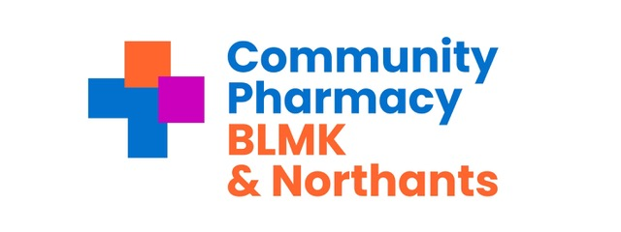
Wednesday 18th March 2026 from 10.30 am

Lupin Healthcare will be covering the venue hire costs associated with this meeting and a sponsored promotional slot and has had no influence on the venue,agenda or speakers.

Attendees:

Nishil Shah - Chair and Independent LPC Member (Retrolink Ltd) NS
Mahesh Shah - Vice Chair and Independent LPC Member (Sampson AP Ltd) MS
Anne-Marie King - Chief Officer AMK
Paul Fearon - Treasurer PF
Ingrid Cruickshank - Services & Engagement Lead BLMK IC
Ann-Marie Carrey Services & Engagement Lead BLMK AC
Rita Patel Services & Engagement Lead Northants RP

Rishi Hindocha - Independent LPC Member (Pharmacy Cherry) RH
Amit Lakhani - Independent LPC Member (Bishopscote Chemist) AL

Lakhminder Flora - LPC Member, CCA representative (Boots) LF
Gordon Ross - LPC Member, CCA representative (Boots) GR
Tahera Dewji- LPC Member, CCA representative (Superdrug) TD

Has Modi - LPC Member, AIMp representative (Jardines - UK Ltd) HM
Conor Steele - LPC Member, AIMp representative (Jardines - UK Ltd) CS
Mohammed Salloo- LPC Member, AIMp representative (Peak Pharmacy) MS

Guests:
Anna Towney- Regional Account Manager – Respiratory Lupin Healthcare
Oliver Staunton- Developer -PharmData

Apologies :
Anil Sharma

Time | Agenda Item | Presenter
10.30 | Welcome and introductions | NS
 | Declarations of Interests | NS
 | Apologies for absence
10.35 | Presentation from Lupin Healthcare   | Anna Towney
10.45 | Treasurer’s update | PF
11.30 | Mini Satheesh Head of Pharmacy Integration and Workforce NHS Northamptonshire ICB
12.00 | LLR Collaborative update | NS
12.20 | Central East LPC Collaborative update | NS
12.40 | Presentation from PharmData (Online) | Oliver Staunton
1pm | Lunch
14.00 | Funmi Balogun Head of Community Pharmacy Integration BLMK ICB
14.30 | Governance (H&S) | Governance sub committee
14.45 | Services to include June 28th planning update | Services
15.15 | CCA Q1 Questions | CCA reps
15.40 | Concluding Comments (future minutes)  AOB if received | NS
16.00 | Close of Meeting | NS

Next Meeting in person Wednesday May 13th 2026

