Digital Transformation – GP Connect
NHS England has significantly improved the digital infrastructure between general practice and community pharmacy to support the implementation of Pharmacy First, and the expansion of the Blood Pressure Check Service and Pharmacy Contraception Service.

Digital improvements is reducing burden and improving patients experience and safety, freeing up general practice appointments for patients who need them most, giving people quicker and more convenient access to high quality healthcare.

GP Connect Access Record: Structured allows registered community pharmacy professionals to securely view areas of the patient’s GP record within their own assured IT system. Information is provided in a structured, standardised format that is user-friendly and easy to interpret. Information is read only and cannot be extracted or stored in community pharmacy systems.
- Access Record: Structured may only be used for NHS direct care and gives registered community pharmacy professionals access to the real-time information they need for safe, informed clinical decision-making.
- Community pharmacy clinical service specifications (e.g. NHS Pharmacy First service specification) outline that with the patient’s consent, a pharmacist must consult the patients GP record, using GP Connect Access Record, National Care Record or an alternative clinical record.
- Community pharmacies will have signed up to the terms of the National Data Sharing Arrangement (NDSA) to use GP Connect on registration with MYS for Pharmacy First, Blood Pressure Check or Pharmacy Contraception Service.
- Areas of Access Record: Structured are already deployed in assured general practice systems, ready for approved clinicians to request. Assured community pharmacy suppliers have started to rollout, providing access to three clinical areas of the patient’s GP record:
- Medications
- Investigations
- Observation items - weight, height, body mass index, pulse rate, smoking status, alcohol intake and blood pressure readings
- Information will only flow through to community pharmacy if the system is enabled with the GP IT system and the patient has not withdrawn their consent.

Note:
- Continue to use National Care Records Service (NCRS) /Summary Care Record (SCR) for allergy information.
- If a general practice has Access Record: Structured turned off, the community pharmacy will see an error message.
- If a patient has requested their patient GP record is not shared, the community pharmacy will see an error message.
- In these instances, community pharmacy professionals should access clinical information via alternative resources, for example NCRS/SCR and ShCR, ask the patient or call the general practice.

What are the benefits of GP Connect Access Record: Structured?
- Time saving: Less time switching between community pharmacy applications, providing role-based access without the need for a Smartcard
- User friendly system: Provided in a structured format which can be filtered. Information not limited to the past 12 months
- Improved clinical decision making: Reducing clinical risk and improving patient outcomes.
- Joined up care: Verifying patient medical history and reducing burden on patient to remember or relay information
- Patient safety: Ensuring community pharmacy have the most accurate, up-to-date information for patient care
GP Connect Update Record: Structured allows registered community pharmacy professionals to send pharmacy consultation summaries in a structured format, including details of any medicines supplied. This goes directly into general practice workflows for filing, rather than via NHSmail or letter. It can only be used for three services.
- NHS Pharmacy First
- NHS Community Pharmacy Blood Pressure Check Service
- NHS Pharmacy Contraception Service

Community pharmacies do not need to take any action to implement GP Connect Update Record: Structured and will not notice any changes to the user interface. Community pharmacy professionals should continue to record and submit consultation summaries into their clinical IT system in the usual way.

What is sent as part of GP Connect Update Record: Structured? Information sent will include:
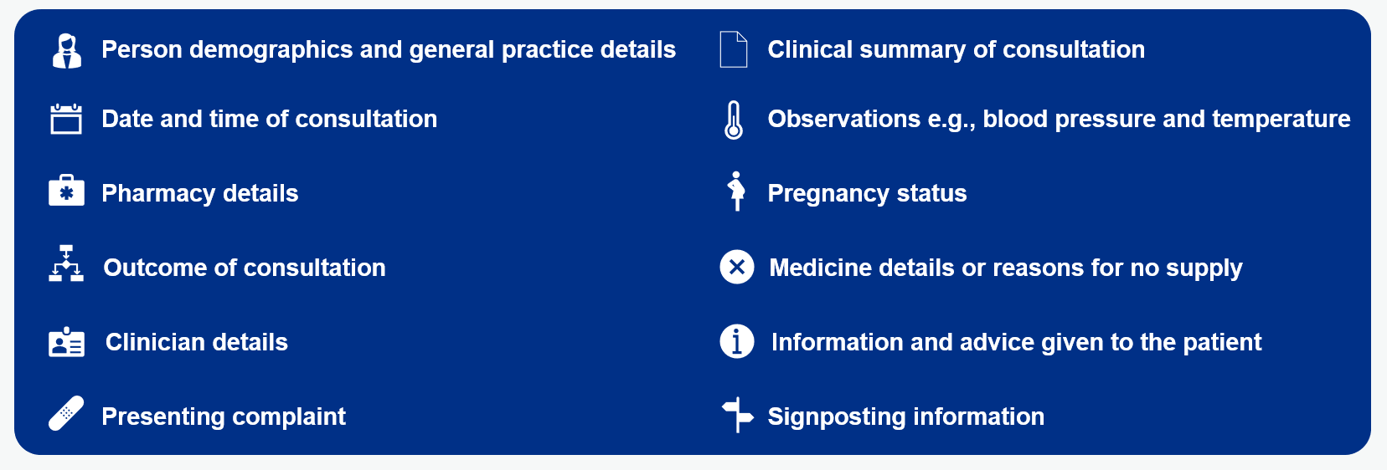

What is not sent as part of GP Connect Update Record: Structured?
- Is not used to communicate urgent actions or referrals where urgent action or an urgent referral to general practice is required, this must be communicated directly, following local processes e.g. NHSmail or telephone.
- Is not used to communicate safeguarding concerns where a safeguarding concern is identified, follow local safeguarding procedures.
- In the case of the Pharmacy Contraception Service consultations, a patient can choose not to have this shared with the GP
  - The community pharmacy registered professional must capture patient consent to share details of the consultation with their GP. Patients should be made aware that a consultation summary and any medicines supplied may be visible in the NHS App and other patient-facing services where this has been enabled by the practice.
  - In these cases, the community pharmacy professional should capture in the pharmacy consultation record that the patient does not consent to the information being shared with general practice.

Note:
- Consultation summaries and medicines may fail to send via Update Record: Structured if the GP IT system is not working or the GP practice has not enabled Update Record: Structured. Community pharmacy must send the consultation summary via NHSmail or letter in accordance with their IT system processes in such cases.
- GP Connect Update Record: Structured has not changed community pharmacy data controller role or responsibilities. Community pharmacy businesses are responsible for the data generated as part of the patient consultation.

What are the benefits of GP Connect Update Record: Structured?

- Improves patient safety: Information on the community pharmacy consultation summary and any medicines supplied is added to the GP patient record as quickly as possible and will be visible to other healthcare professionals, improving clinical decision-making. This will reduce the risk of over-prescribing and increasing antimicrobial resistance. It also reduces errors caused by manual transcription.
- Saves administrative time: Community pharmacy consultations are shared with general practice in a structured and coded format directly into the workflow in GP IT systems for filing in the patient’s GP records, making it quick and easy to review. A workflow task is created so it is visible to the practice before filing into the patient’s GP record with one click. General practice and community pharmacy staff will spend less time manually sending and transcribing information from NHSmail or letters.
- Shares information faster: When GP patient records are updated more quickly, healthcare professionals in other care settings have faster access to information in the summary care record application; and patients have faster access via patient-facing services such as the NHS App.

