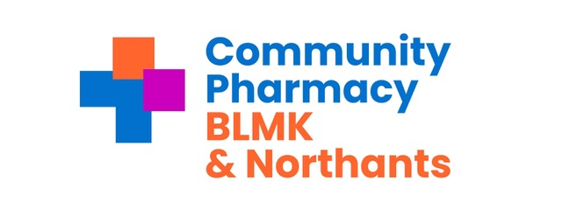
Weekly Newsletter – w/c 1 April 2024
National Updates
NHS prescription charge of £9.65 to roll over into April.
The Department of Health and Social Care (DHSC) is currently unable to confirm whether the NHS prescription charges will be uplifted in 2024.

Pharmacy technicians to be given greater powers to supply and administer medicines.
The Department of Health and Social Care (DHSC) has announced plans to update legislation which will enable registered pharmacy technicians to supply and administer medicines under a patient group direction (PGD).

Extended FP34C submission deadline for prescriptions dispensed in March 2024.
With Easter Monday (1 April 2024) occurring in the first five days of the FP34C submission window, pharmacy owners will have an extra day, until the end of 6 April 2024 to submit their March FP34Cs using the MYS portal and to dispatch their prescription bundle to the relevant pricing division NHSBSA.

Community Pharmacy Contractual Framework: Negotiations for 2024/25
The start of April 2024 marks the end of the five-year Contractual Framework arrangement which was agreed in the summer of 2019.
Negotiations on the arrangements for the coming financial year, 2024/25, are still in progress between CPE, DHSC and NHS England.
Until these negotiations have concluded, fee levels will remain the same and existing service arrangements will continue as previously announced.

Local News
For Luton & Bedfordshire only – From HUC re NHS 111 and Pharmacy First.
This line is accessed by calling 111 and selecting option 3, whereby they will arrange for a healthcare professional to callback. Where appropriate, pharmacists should utilise the healthcare professional line rather than advising patients to call 111 – this will ensure the patients issue is dealt with as efficiently as possible.

Training & Events
Pharmacy First Training Day – Northants.
Pharmacists regularly working in Northamptonshire are now invited by Northamptonshire ICB and the LPC to attend Pharmacy First training. Details of date, times and location can be found on the BLMK-N-LPC website.

Reminders
New eligible patient groups for LFD service start from 1 April 2024.
Community Pharmacy owners are reminded that the lateral flow device tests supply service for patients potentially eligible for COVID -19 treatments (LFD service) will expand to additional patient groups from 1 April 2024.

Medicines
General:
MHRA Drug Safety Update March 2024.
March 2024 Price Concessions 3rd and Final Update.
Government imposes Drug Tariff changes to manage margin.
Newly launched FreeStyle Libre 2 Plus Sensors enter the Drug Tariff and DND list from April 2024.
Rybelsus tablets re-classified as a special container.
Medicines not covered by the HRT PPC.

Medicines Supply Notifications:
Diazepam 10mg/2.5ml rectal solution tubes.
Guanfacine (Intuniv) 2mg and 3mg modified – release tablets.

Title
Email: office@blmk-n-communitypharmacy.org.uk

